Procedures for Validating Traffic Detection Technologies

Transportation Management Center
Hennepin County Traffic Operations

Draft

May 20, 2025

Table of Contents

1. Purpose 1
2. Procedures 1
3. Approach Count Accuracy 1
3.1 Baseline Data 1
3.2 Detector Data 1
3.3 Comparisons 1
3.4 Acceptance 1
4 Turning Movement Account Accuracy 2
4.1 Baseline Data 2
4.2 Detector Data 2
4.3 Comparisons 2
4.4 Acceptance 2
5 Test Scenarios 2
6 Configuration and Calibration 3
7 Maintenance 3
Appendix A: Sample Results 3

Purpose
This document describes the procedures that Hennepin County uses as a guide to validate the accuracy for any intrusive and non-intrusive traffic detection technologies for collecting traffic count data.

Procedures
The procedures describe details in assessing detection accuracy for approach and turning movement count volumes.

Approach Count Accuracy

Baseline Data
Baseline approach counts should be collected in 15-minute intervals by manual observations during the AM Peak (6:00 am – 9:00 am), Midday Peak (11:00 am – 1:00 pm), and PM Peak (3:00 pm – 6:00 pm). A minimum of 300 vehicles should be observed during each peak hour to meet the desired 95% confidence interval. Both entering and exiting traffic should be counted on each approach unless detailed turning movement count data will be collected on all legs of the intersection. In that case the exiting approach volumes can be calculated. The counts should be aggregated to approach and intersection levels.

Detector Data
Detector data should be collected by either counting the response of each virtual detector using manual observations or downloading the vehicle presence detection data from the detector for the same time interval of baseline data collection. Data should be obtained for vehicles entering and exiting the intersection on each approach.

Comparisons
Comparisons should be performed between detector data and manual counts at movement, approach and intersection levels for the time intervals when a minimum of 300 counts are observed. Mean absolute percent error (MAPE) should be used to quantify the differences between detection counts and manual counts. Percent Error should be used to determine if the detector is over or under counting. If the percentage difference is positive, it indicates that the detector over counts vehicle presence. If the percentage difference is negative, it indicates that the detector under counts vehicle presence. Median Error (Bias) % should be viewed to ensure there is minimal bias with the data, generally less than 3%

Acceptance
Based on a minimum sample of 100 observations for each approach over a total of 3 hours it is considered acceptable if the MAPE is less than 5% and the acceptable MAPE value can be found in the table below. Additionally, the Median Error (Bias) % must be below 3%. This applies to the AM Peak, Midday Peak, and PM Peak.
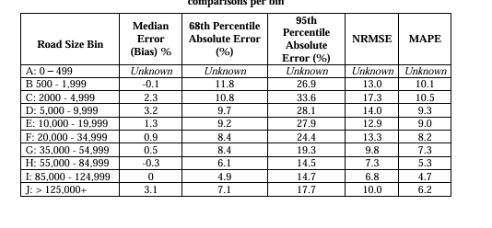

Turning Movement Account Accuracy

Baseline Data
Baseline turning movement counts should be collected in 15-minute intervals by manual observations during AM Peak (6:00 am – 9:00 am), PM Peak (3:00 pm – 6:00 pm), and Off Peak (11:00 am – 1:00 pm). A minimum of 100 counts should be observed at movement level for each data collection period to meet the desired 95% confidence interval. The counts should be aggregated to approach and intersection levels.

Detector Data
Detector data should be collected for each movement by downloading the logged data via detector interface software for the same time interval of baseline data collection. The data should be converted into a spreadsheet format with time stamps and aggregated counts to approach and intersection levels for comparison.

Comparisons
Comparisons should be performed between detector data and manual counts at movement, approach and intersection levels for 15-minute intervals, hour intervals, as well as aggregated AM Peak, PM Peak and Off-Peak periods. Percentage differences should be used to quantify the differences between detection counts and manual counts which are considered as the baseline. If the percentage difference is positive, it indicates that the detector double counts the traffic. If the percentage difference is negative, it indicates that the detector under counts the traffic.

Acceptance
Based on a minimum sample of 100 observations for each movement for one hour it is considered accurate if the MAPE is less than 5% and acceptable if the MAPE is less than 10% for each of the three hours in the AM Peak, Midday Peak, and PM Peak.

Test Scenarios
The test should be conducted under different weather conditions including snow and raining conditions.

Configuration and Calibration
The assessment should focus on how many parameters need to be configured and adjusted in addition to the default values to obtain accurate presence and turning movement count detection. The interface should provide real-time vehicle presence and turning movement count detection validation feature.

Maintenance
Any maintenance to the detection equipment that involves moving it or any adjustments to the detection zones will render all subsequent data invalid until the validation process can be repeated. If the data is validated without any adjustments, then all data collected after the adjustments is assumed to be now valid.

Appendix A: Sample Results

Table 1: Interval Level Turning Movement Count Comparisons between Detector Counts and Manual Counts (Percentage Difference)
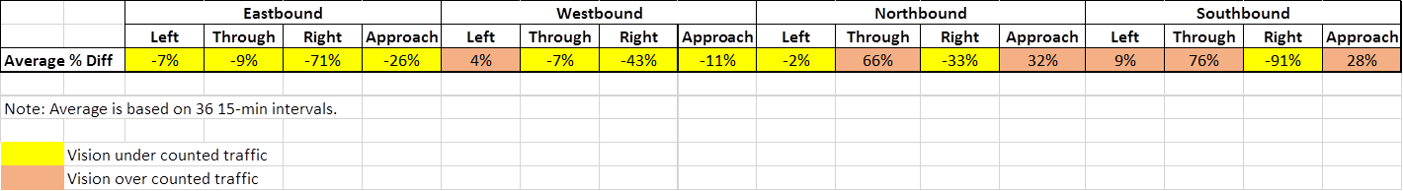

Table 2: Hourly Turning Movement Count Comparisons between Detector Counts and Manual Counts (Percentage Difference)
